**Application Development**

**OPSC7311 Assignment 2**

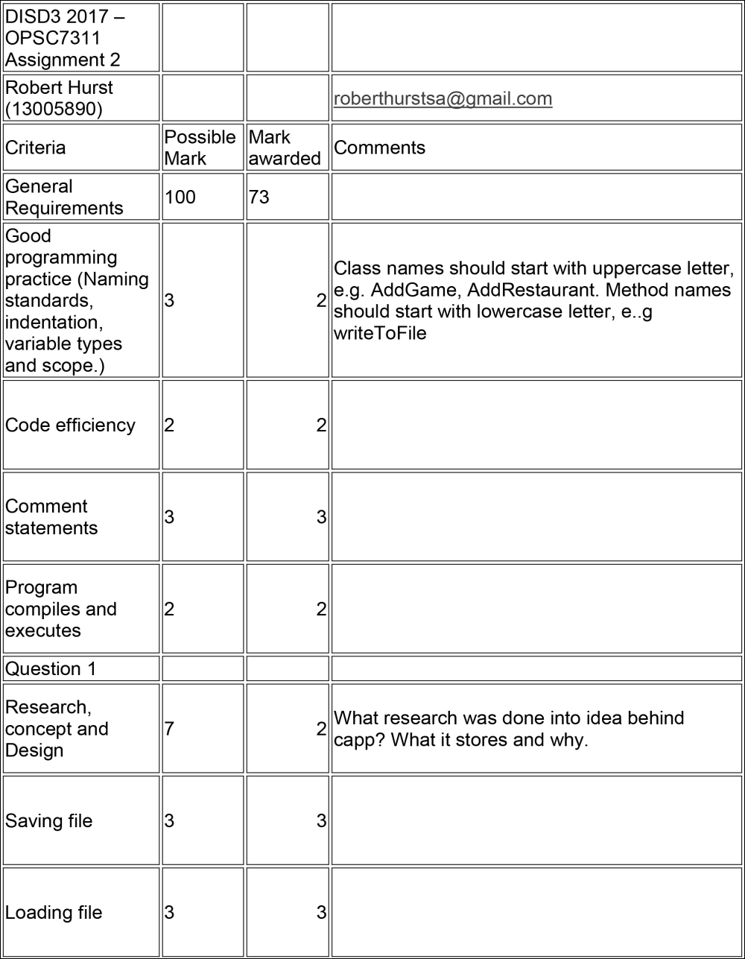

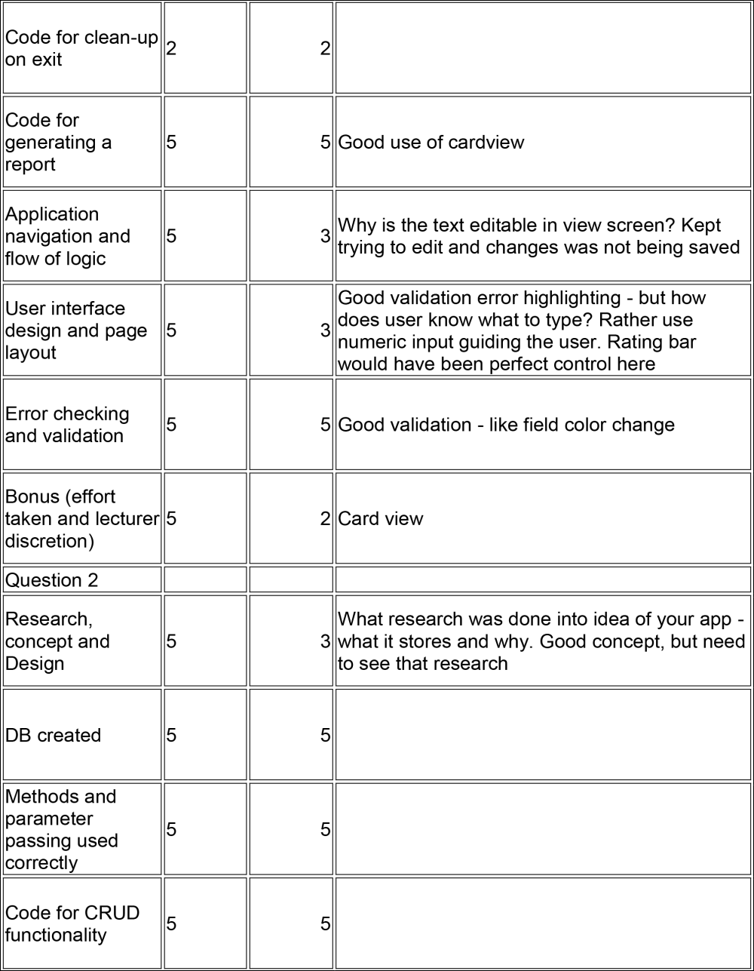

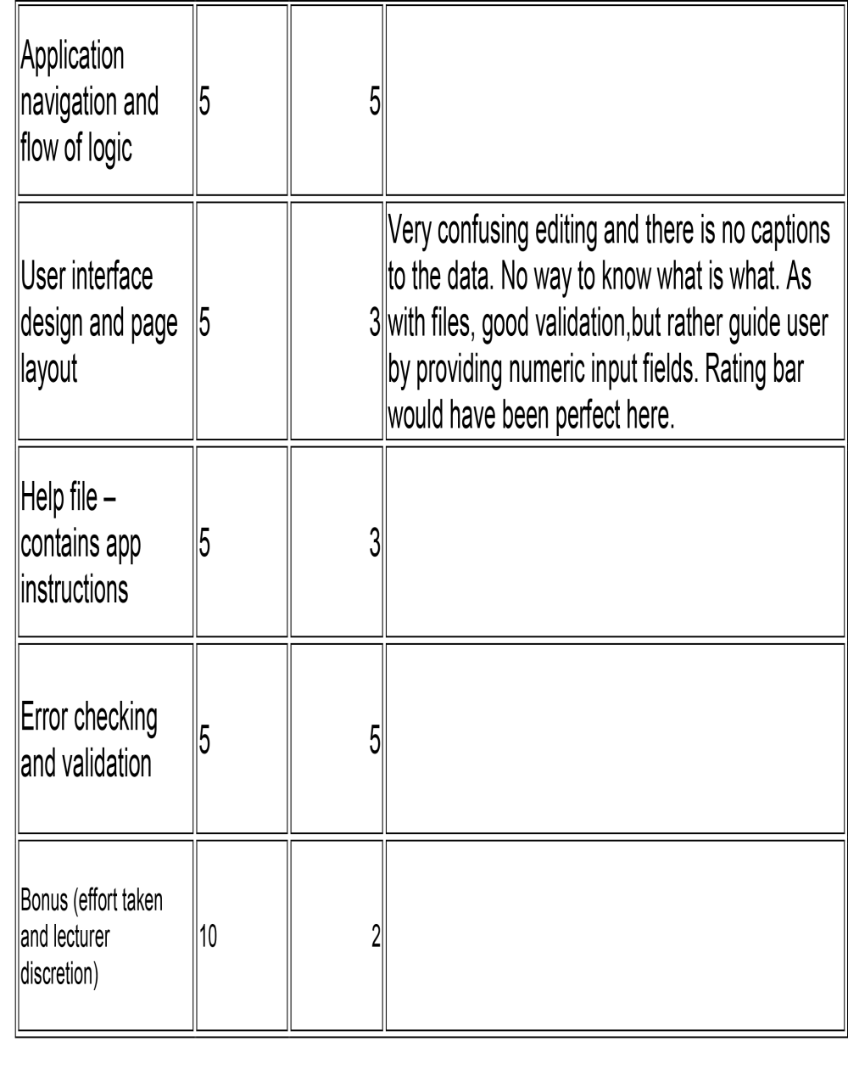

**Changes**

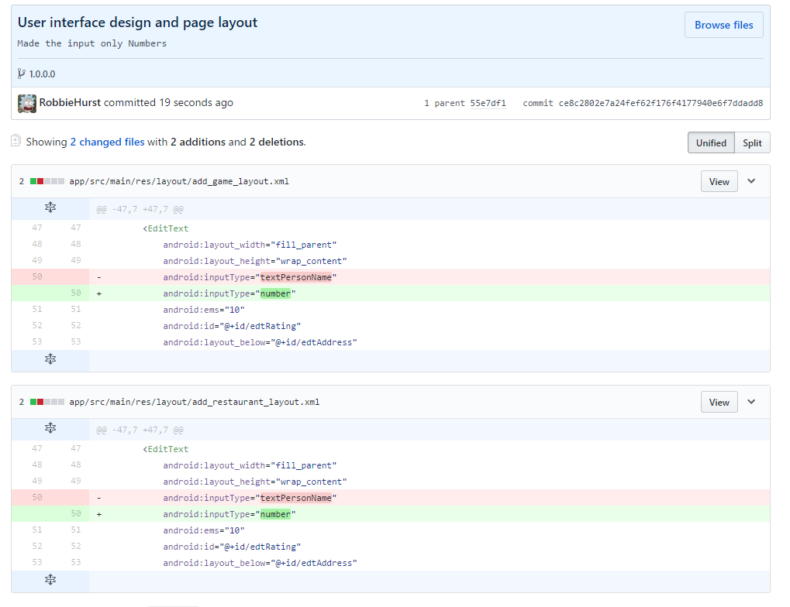I made the change based on the feedback to ensure that the user entered a number for the rating by making the input keyboard a number based keyboard.

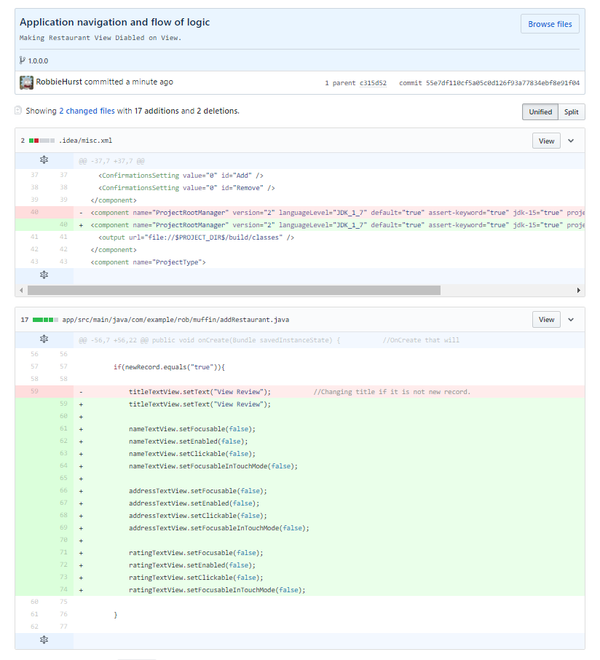

I also made the change so that the user cannot try to edit the text views when a tap on an item in the restaurant program. I have set the textviews to disabled essentially when there is a specific condition.